Ref. No: Date: 25/11/2023

Notice Regarding 5th Semester PROGRAMME Internal exam
It is hereby notify to all students of 5th semester PROGRAMME that an internal exam will be held on 16/12/2023 (Saturday) at room no 304. All must come with pen, writing board and old admit card.

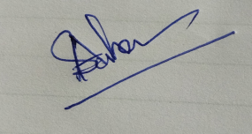
HOD
Department of Chemistry

